ALTER VIEW [dbo].[PAR_CUSTOM_VW_WELL_LEVEL_GAS_VOLUME_DATA]

* Added [yield /BBL] calc to well level.
* Pulls in dynamic POP% for each well.

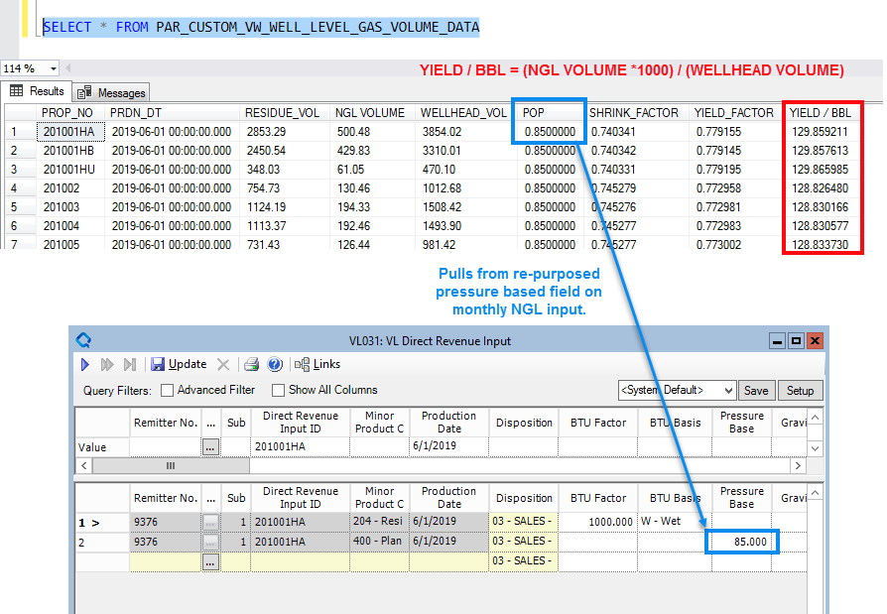

ALTER VIEW [dbo].[PAR_CUSTOM_VW_PLANT_AVG]

* Adds Yield /BBL calc average to purchaser level

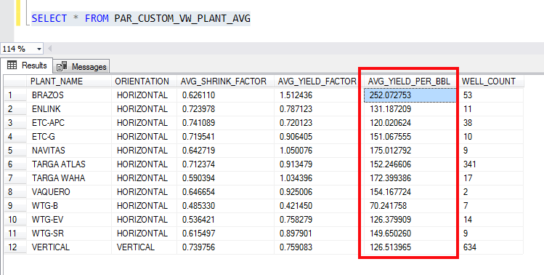

ALTER VIEW [dbo].[VW_WELL_NRI_POP_LIST]

* Pulls in changes from other views, centralizes, and organizes them.

